**EXECUTIVE SUMMARY**

This report outlines the development of key information security policies for Cyanide Ltd, ensuring alignment with ISO 27001 standards and enhancing the organization’s security posture. The policies cover Information Security, Information Classification, Identity Management and Access Control, Privilege Account Management, Secure Configuration, Incident Management, Clear Desk and Clear Screen, Risk and Compliance, Supply Chain Security, and Acceptable Use. Each policy is mapped to relevant ISO 27001 domains and sub-domains, and specific guidelines are provided for their implementation. Recommendations are included to ensure the successful implementation and continuous improvement of the security framework.

1. **Information Security Policy: Domain:** Information Security Policies (A.5) **Sub-Domain:** A.5.1.1 Policies for information security. **Control Number:** A.5.15, A.5.32, 5.34, A.5.26, A.5.36

The purpose of this policy is to protect the company’s information assets from threats, internal or external, deliberate or accidental; to ensure compliance with legal, regulatory and contractual requirements and to foster a security culture among our staff and organization as a whole. It establishes clear security objectives aligned with business goals, esnuring confidentiality, integrity and availability of information by defining clear roles and responsibilites for our information security management across the organization. It applies to all employees, contractors, vendors and other parties who have authorized access to Cyanide’s information systems, including all hardware, software, networks, data and it covers all forms of information, including digital, physical and intellectual property. Cyanide is committed to ensuring the security of its information assets by implementing and maintaining an effective information security management system.

By adhering to this policy, Cyanide Ltd aims to protect its information assets, maintain trust with stakeholders, and ensure the continued success of its operations in a secure and compliant manner. This Policy 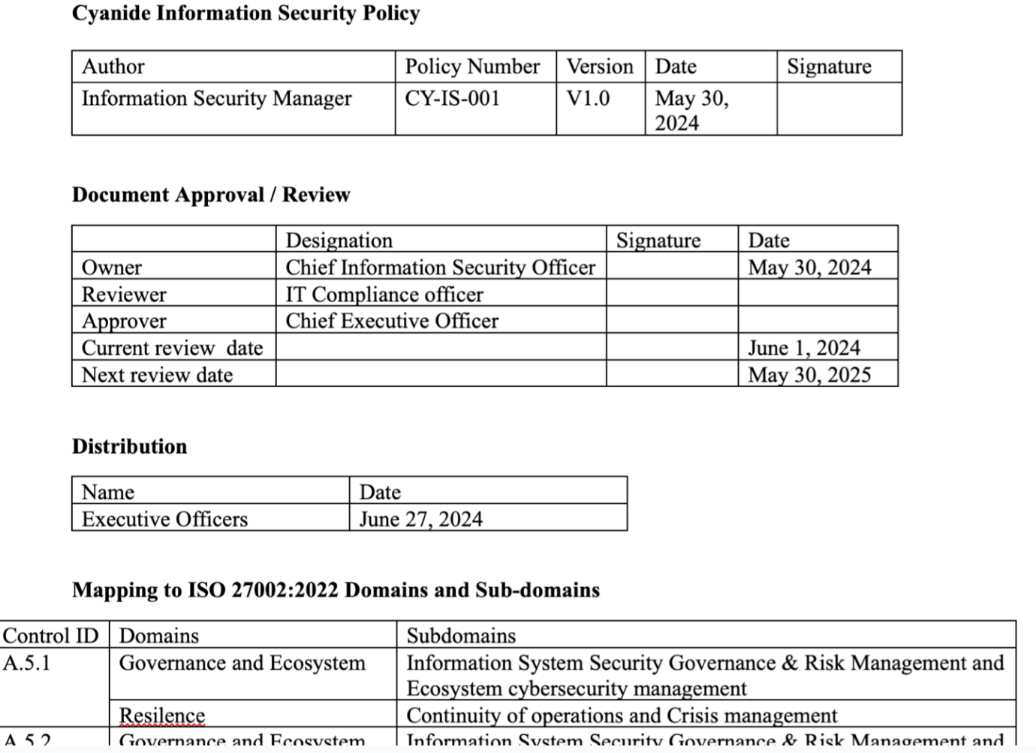

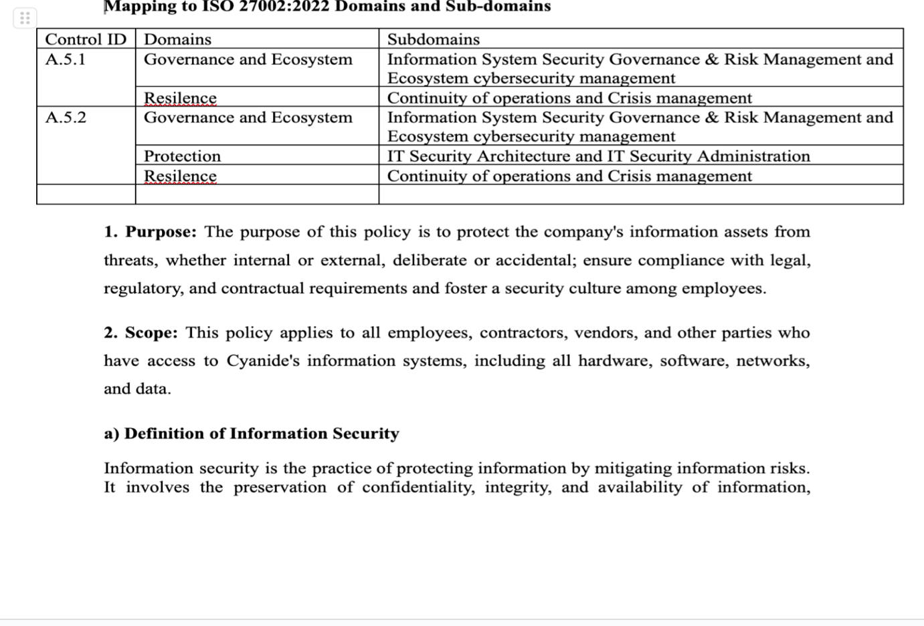

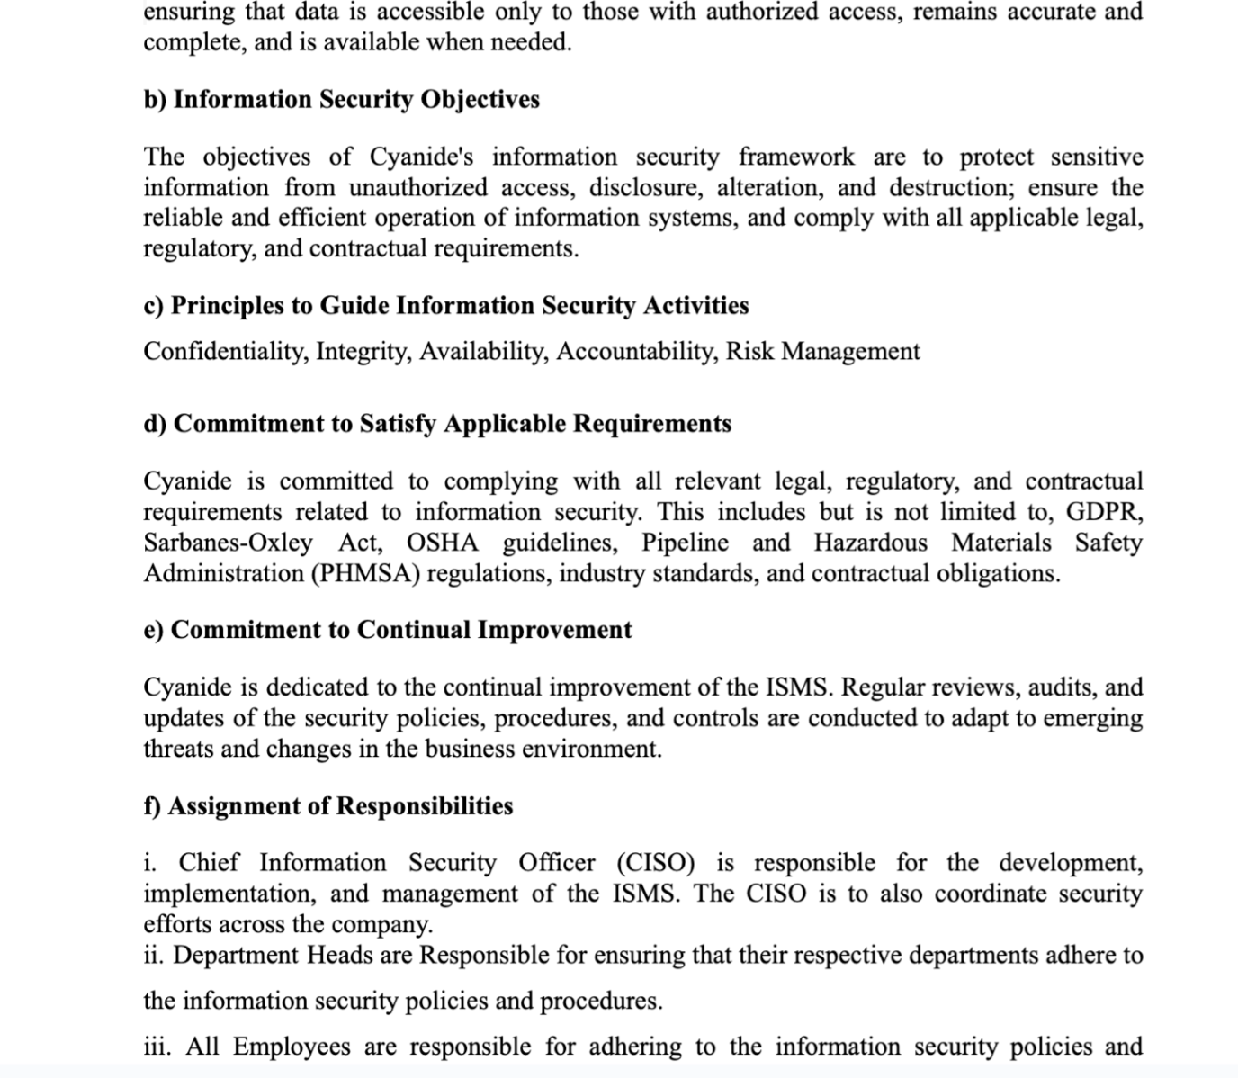

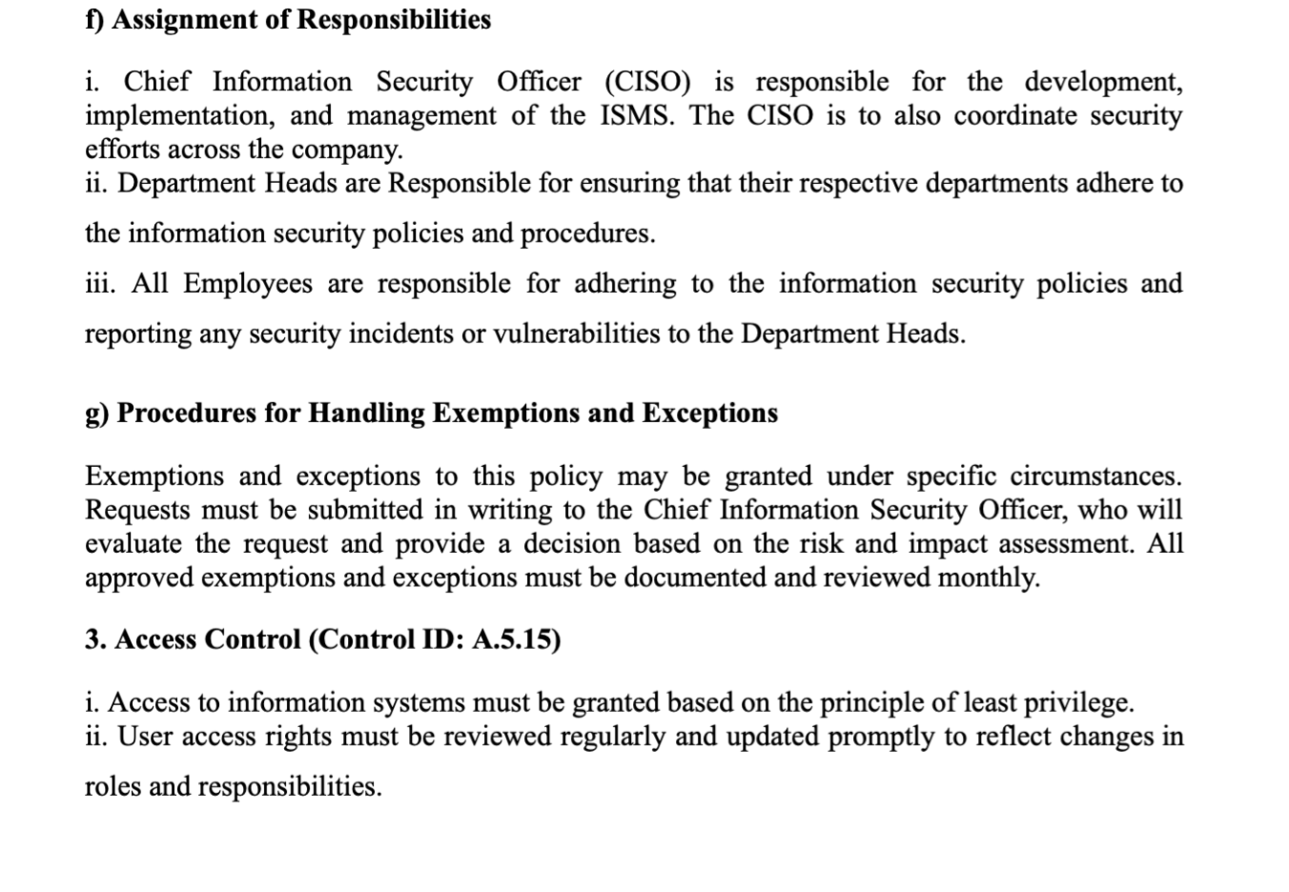

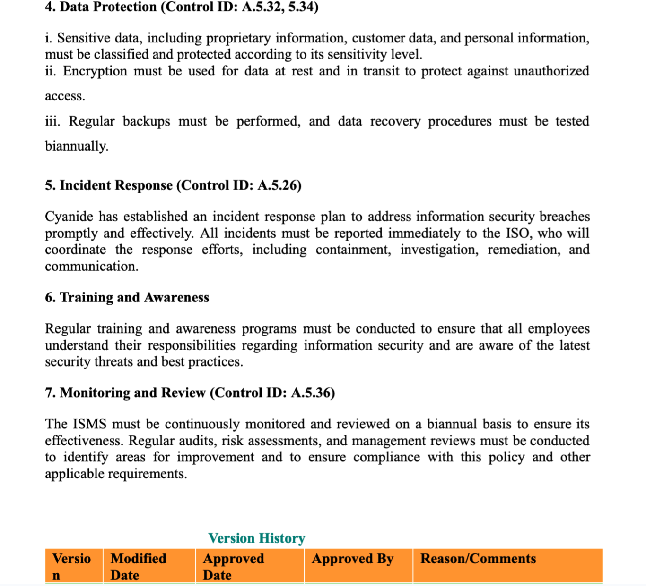

***Fig.1: Information Security Policy***

1. **Acceptable Use Policy: Domain:** Information Security Policies (A.5, A.7.3) **Sub-Domain:** A.5.1.1 Policies for information security. **Control Number:** A.5.1.1, 5.10, 5.18,  5.36,5.4, 6.3)

The Acceptable Use Policy (AUP) for Cyanide sets forth the standards and expectations for the use of the company's information systems, networks, and resources to ensure their secure, efficient, and ethical utilization. This policy mandates that all users access and use company assets solely for legitimate business purposes, in compliance with applicable laws, regulations, and company policies. It prohibits activities that could jeopardize the security, integrity, or availability of the company's systems and data, including unauthorized access, data breaches, misuse of resources, and any actions that may harm the company's reputation or operations. This policy encompasses all employees, contractors, vendors, and any other third parties who have access to the company’s information systems, networks, and resources. This policy applies to all forms of access and usage, By establishing clear guidelines for acceptable and unacceptable behavior, this policy aims to protect Cyanide Ltd critical infrastructure, foster a secure working environment, and promote a culture of accountability and security awareness among all users.

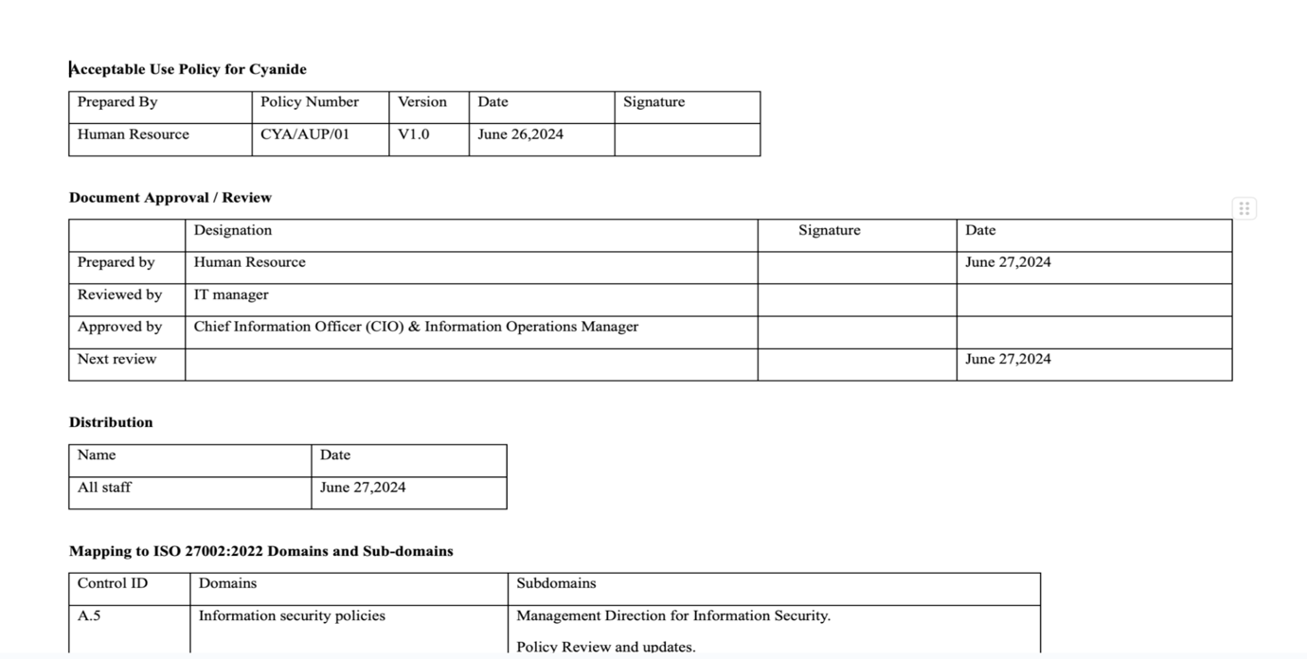

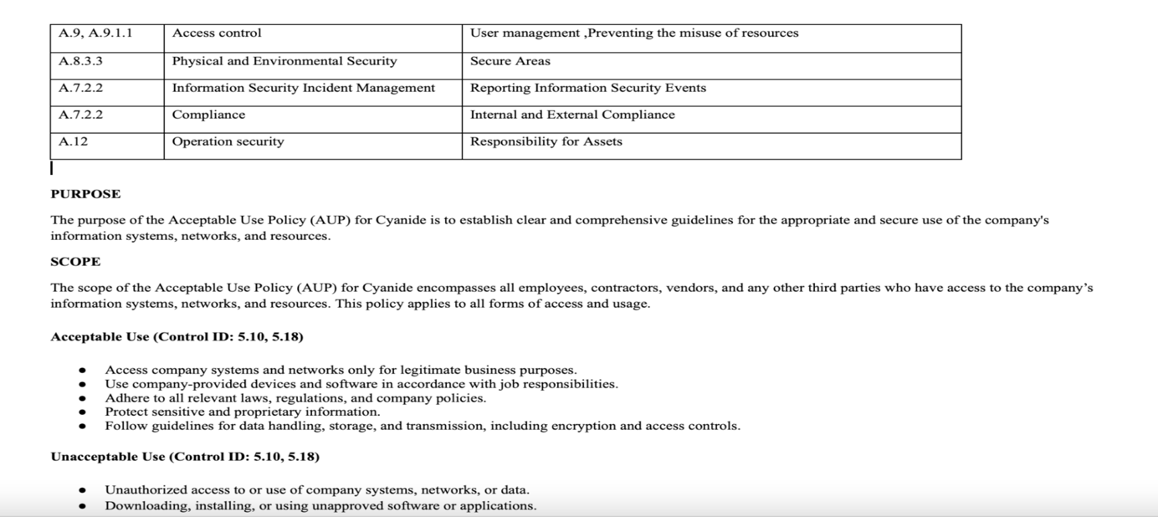

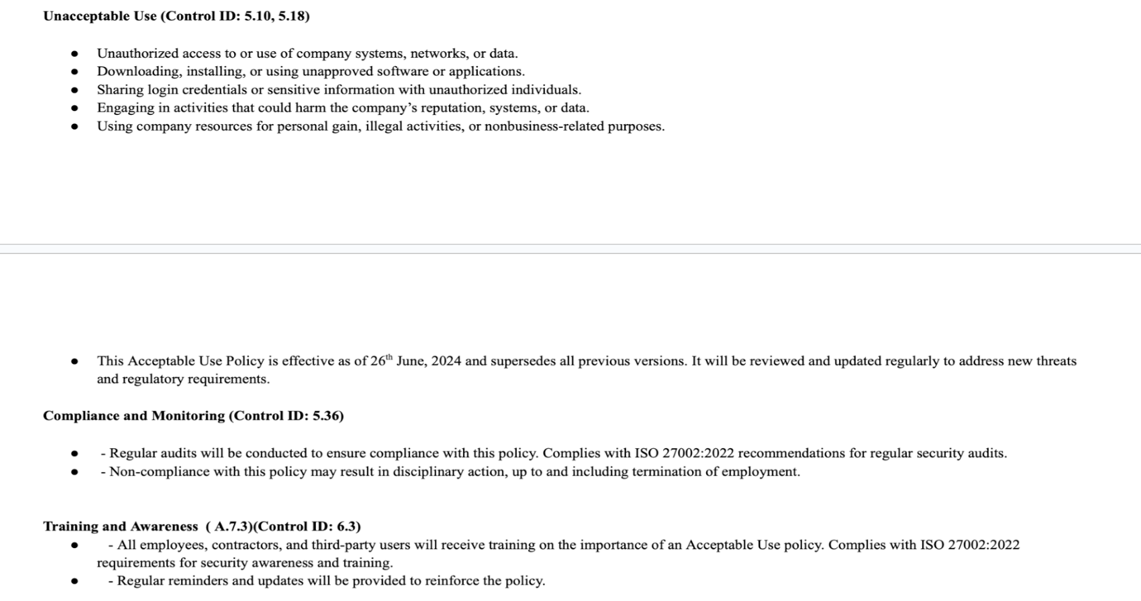

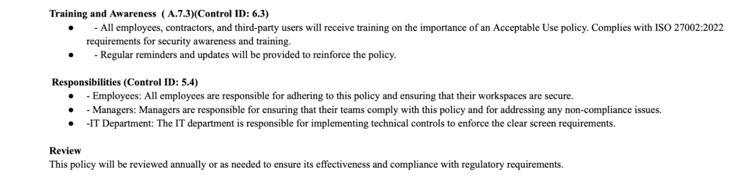

1. **Clear Screen and Clear Desk Policy: Domain:** Physical and Environmental Security (A.11), Asset Management (A.8), Human Resources Security (A.7), Access control (A.9),  **Sub-Domain:** A.7.7 Clear Desk and Clear Screen Policy **Control Number:** A.5.1.1

This policy seeks to ensure that sensitive information is protected from unauthorized access, minmise the risk of information theft, loss or unauthorized disclosure and promote a clean and organized work environment. It applies to all employees, contractors and third party users who have access to sensitive information both physical and digital. It requires users to lock their workstations when unattended and clear their desks of all papers, documents and electronic media when leaving their workstation unattended especially at the end of the day and to ensure that sensitive documents are stored

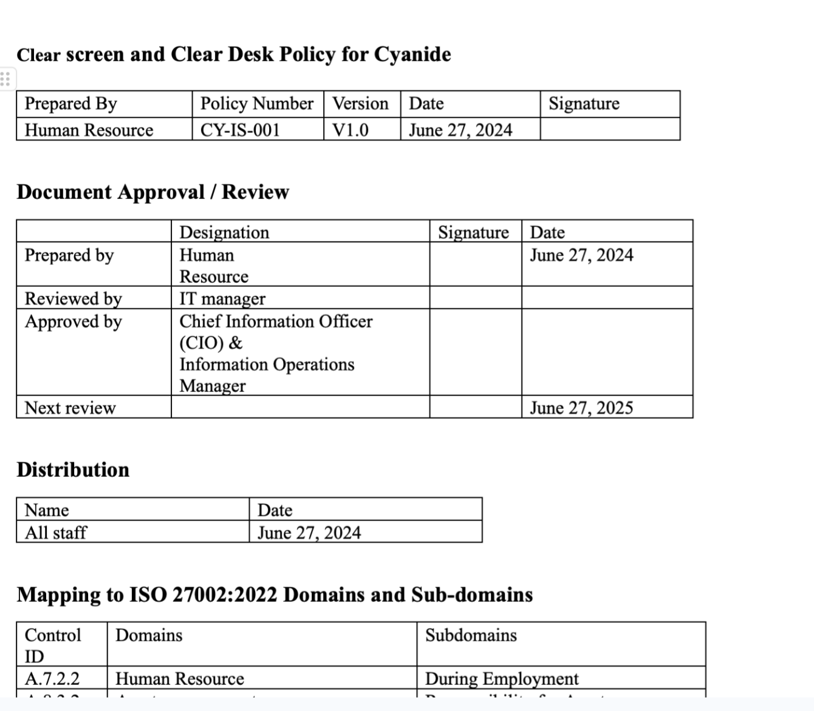

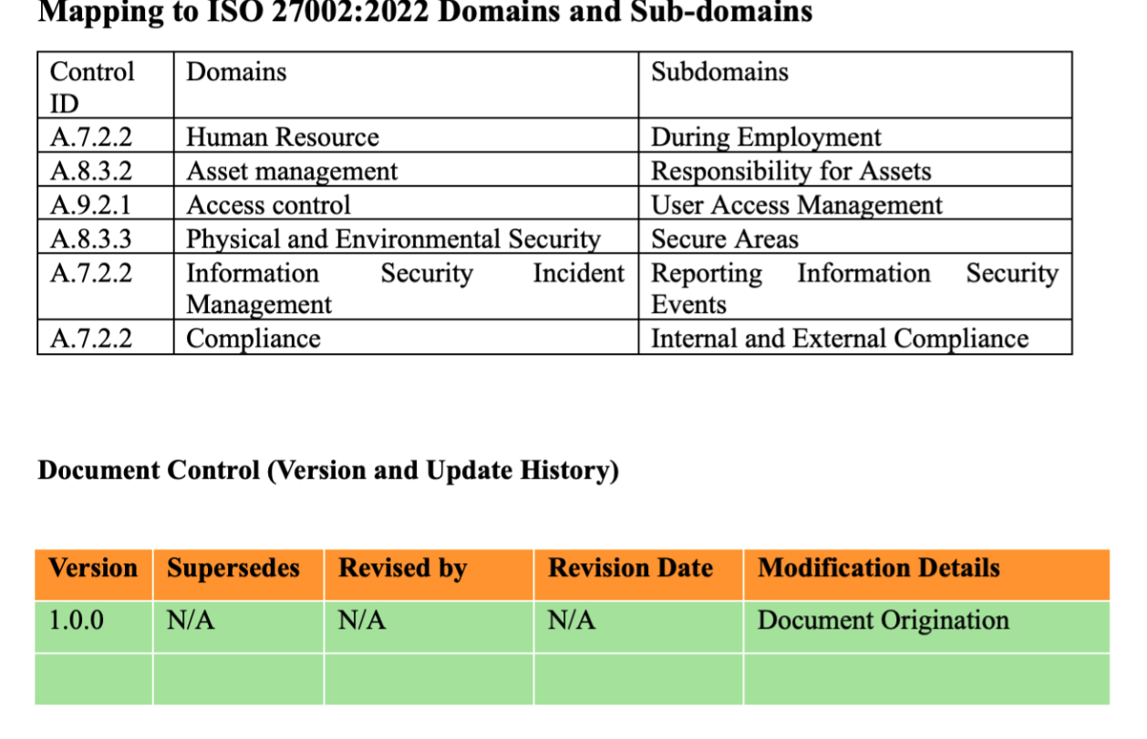

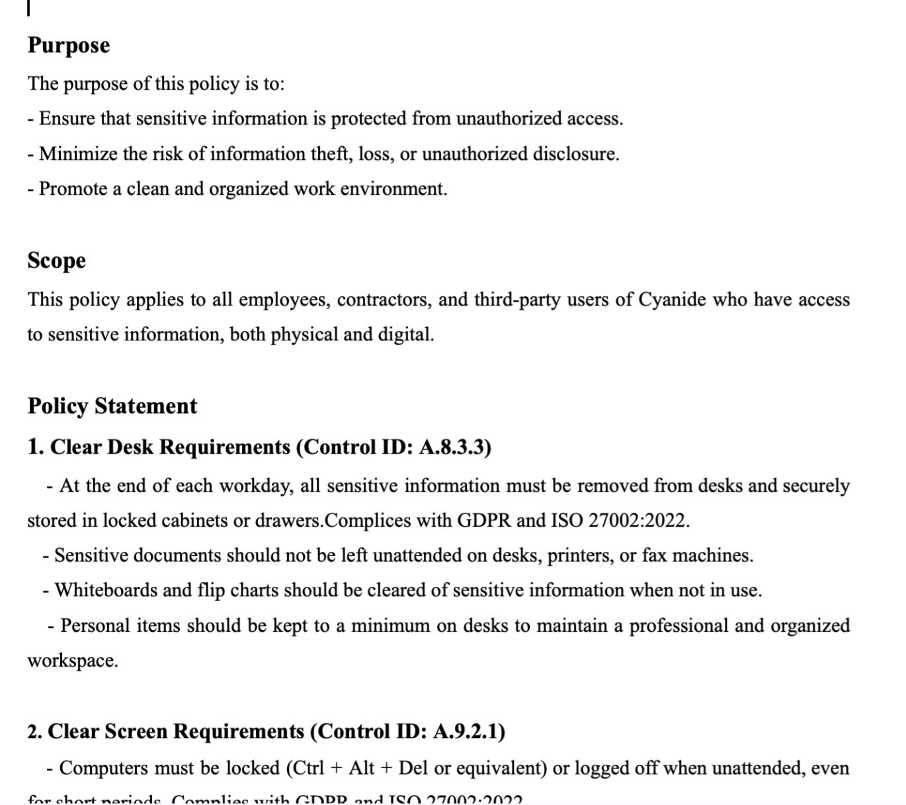

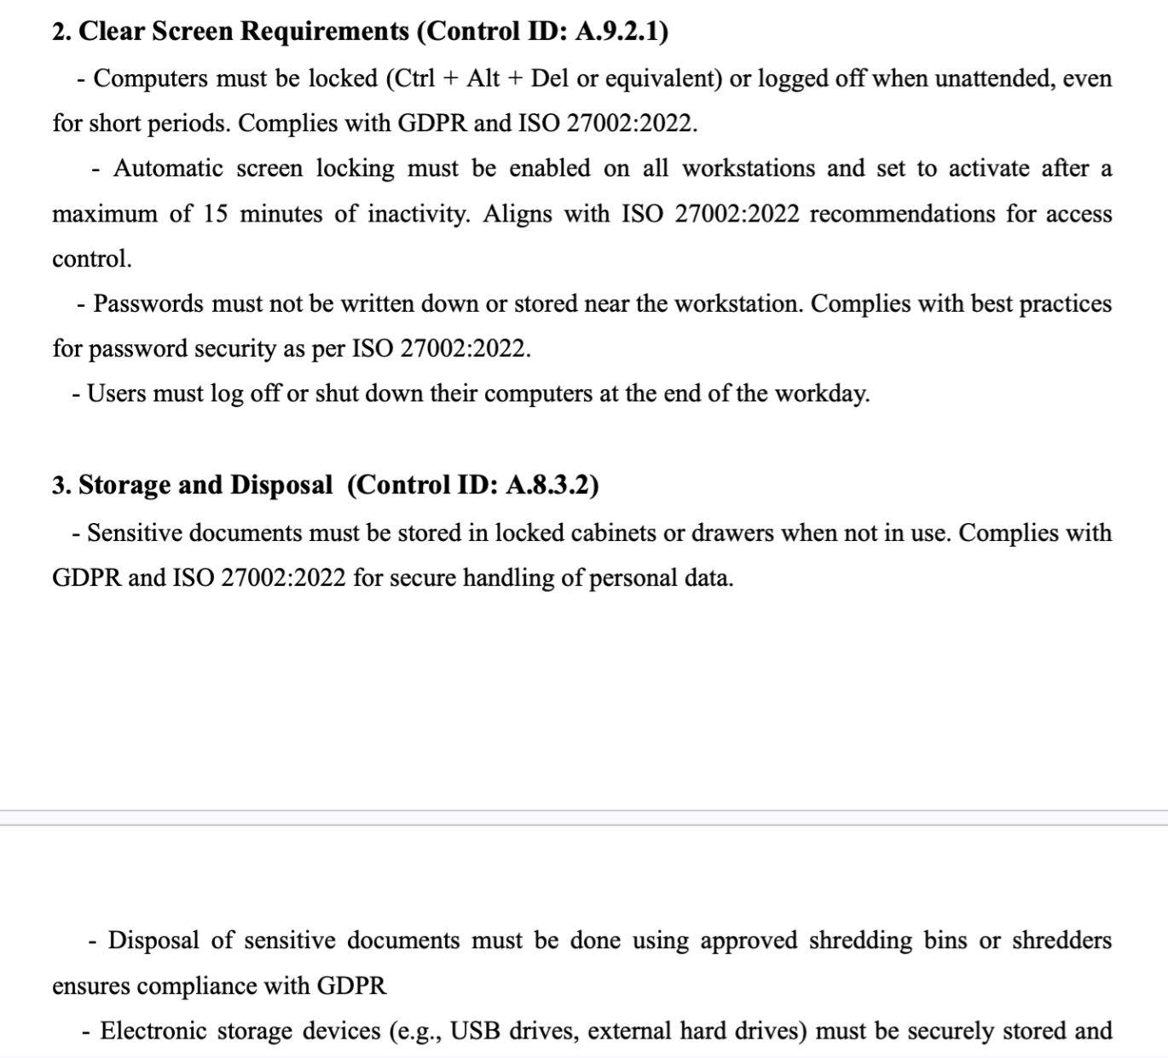

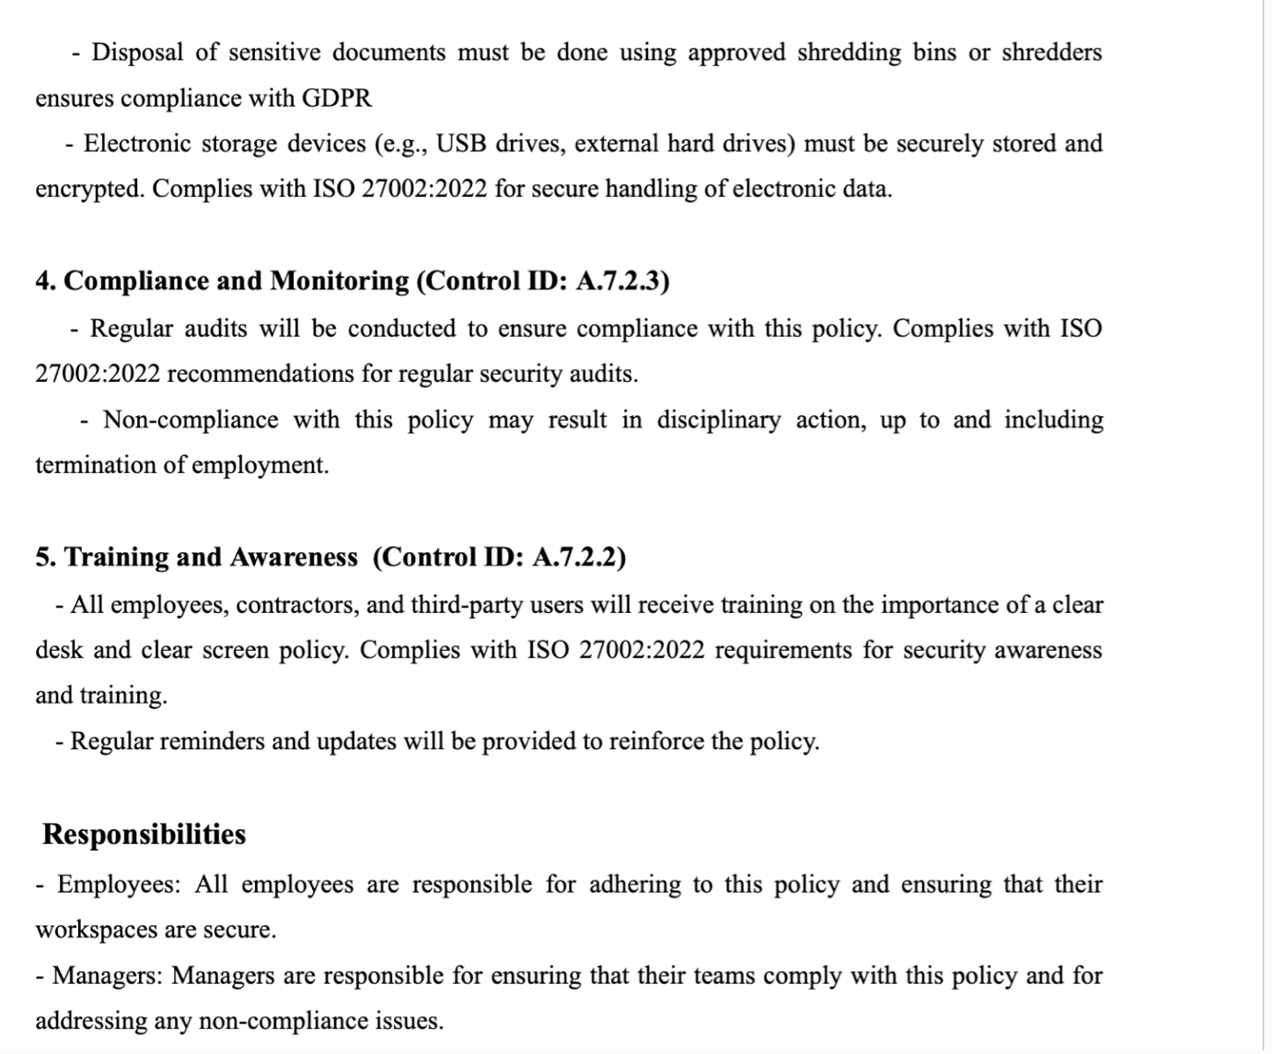

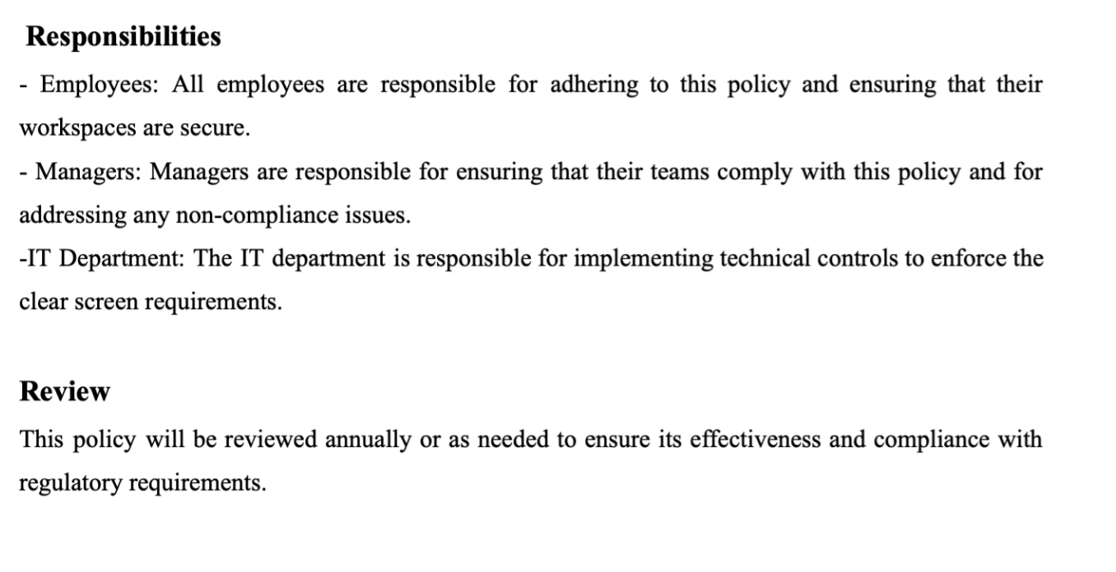

1. **Incident Management Policy: Domain:** Organization of Information security (A.6), Information security incident management (A.16), **Control ID:** 5.24. 5.25, 5.26, 5.27,5.28.

This policy seeks to establish a framework for identifying, reporting, investigating, containing, mitigating, recovering and learning from incidents in the Oil and Gas industry to minimize risks and ensure compliance with relevants regulations and the ISO 27001. It applies to all staff, contractors and third parties involved in Cyanide operations. It covers incidents related to process safety (fires, explosions), security (cyberattacks), environment (pollution), occupational health and safety (injuries, illness) and business continuity (operational disruptions).

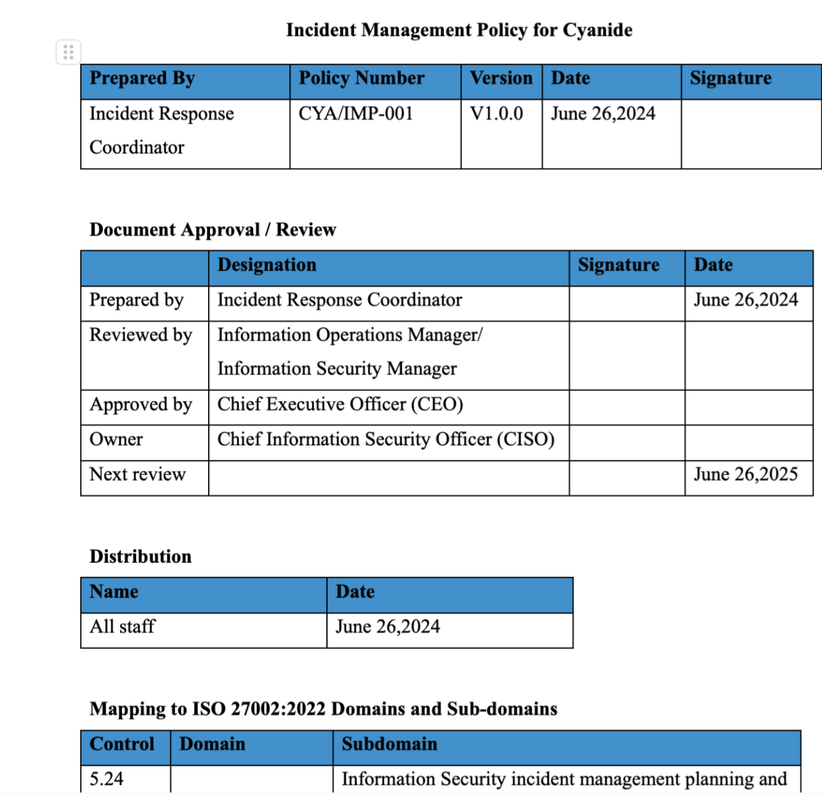

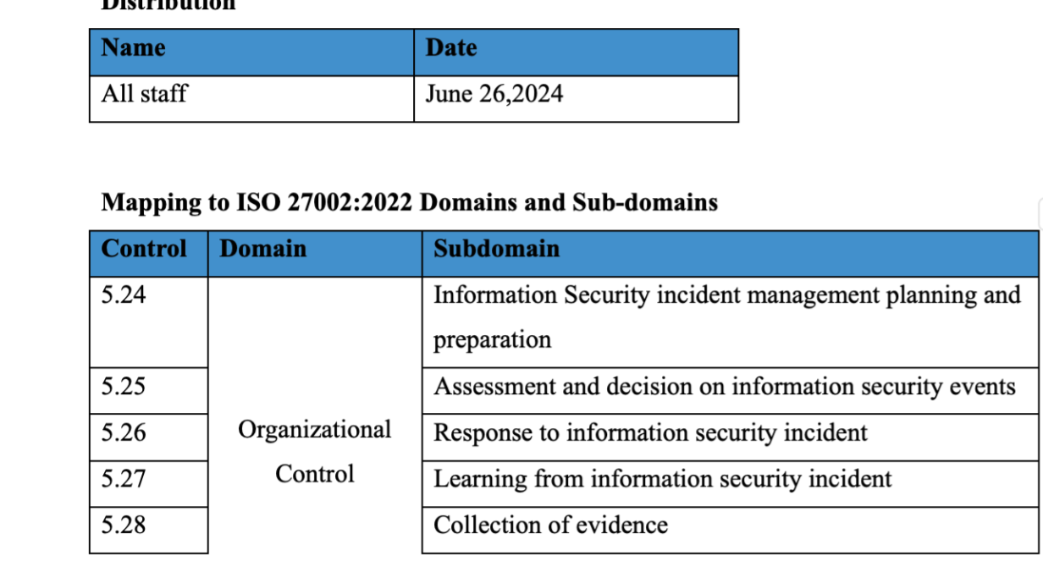

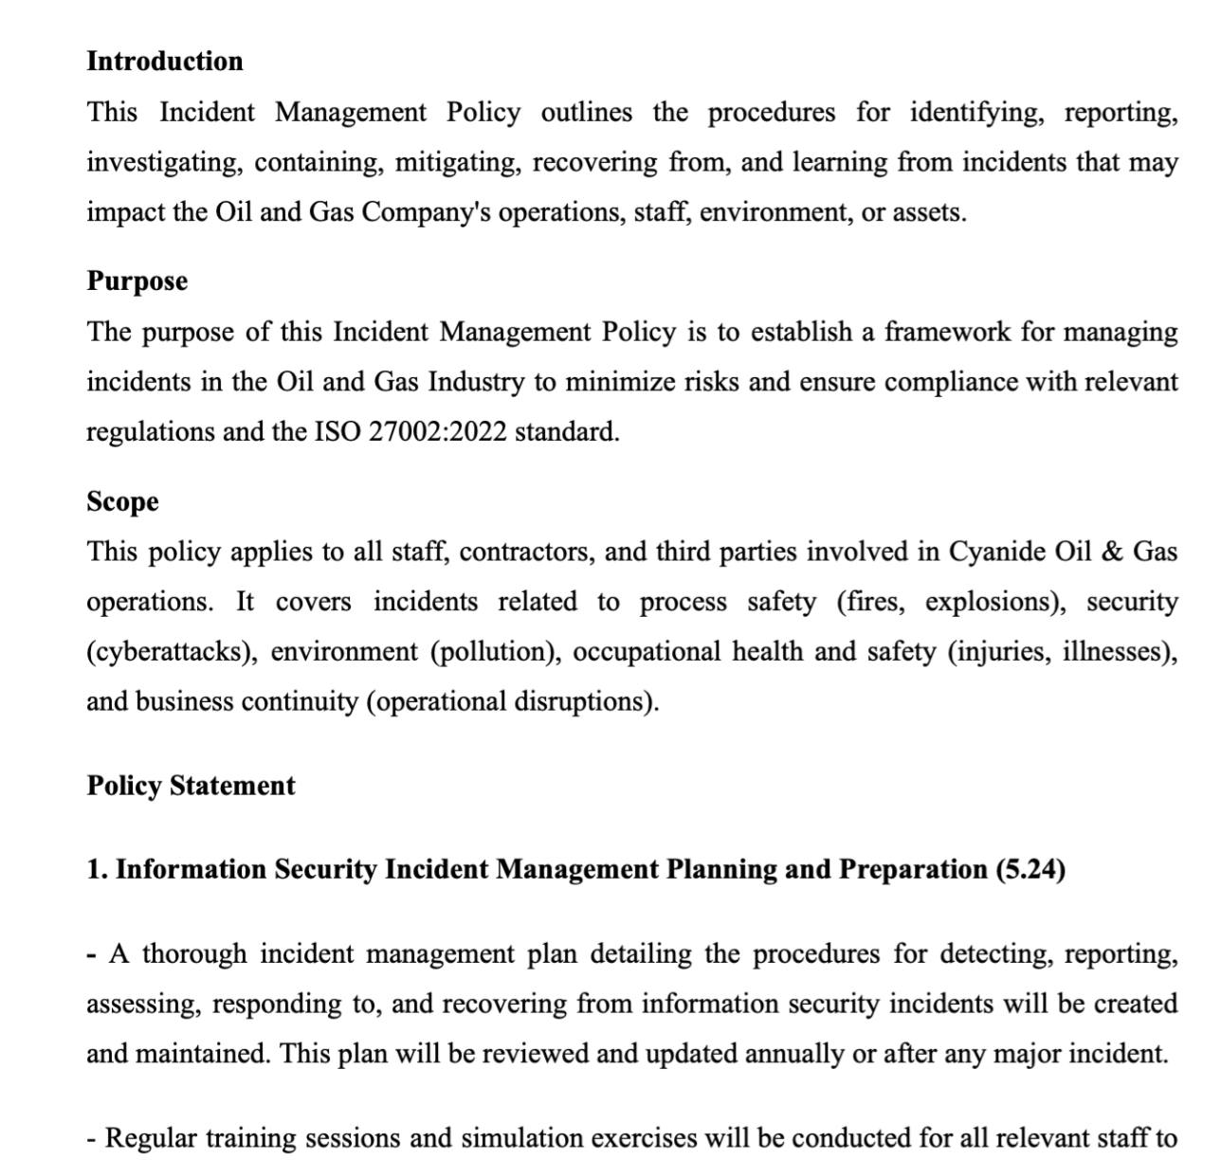

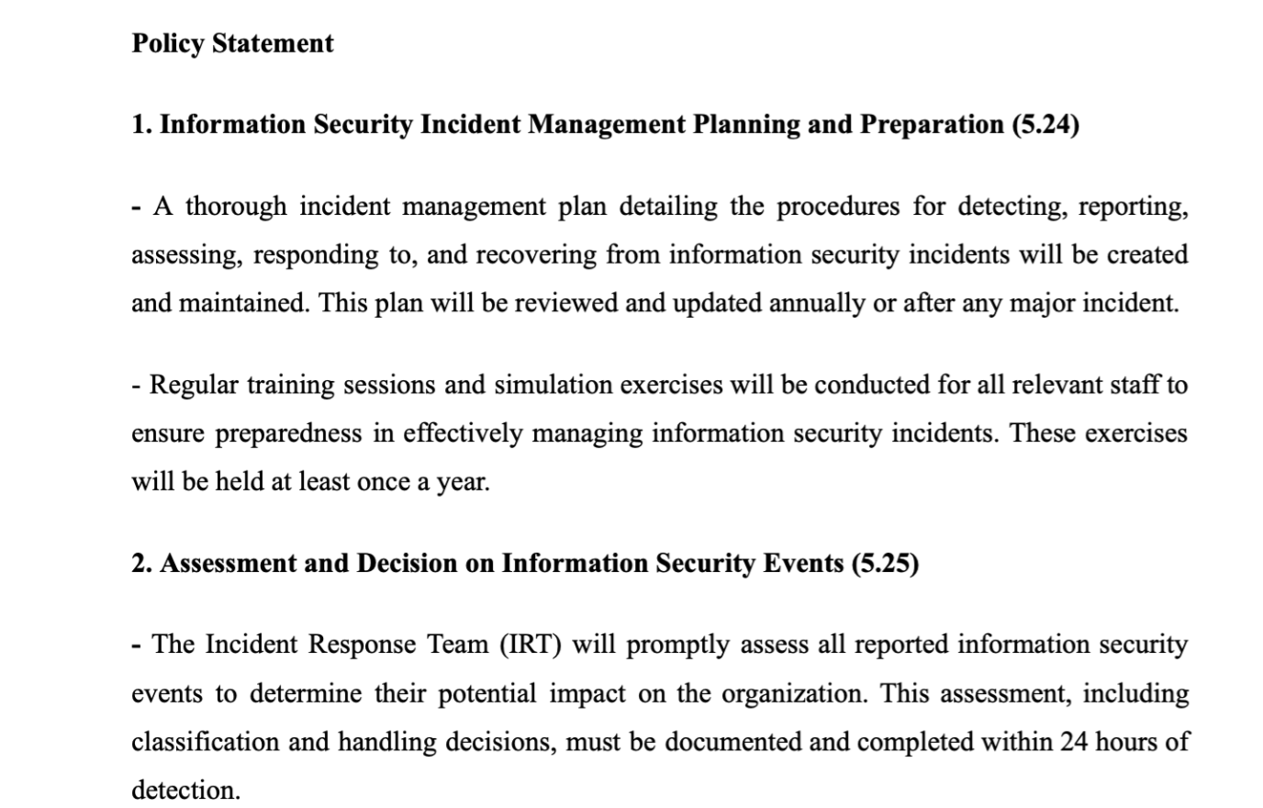

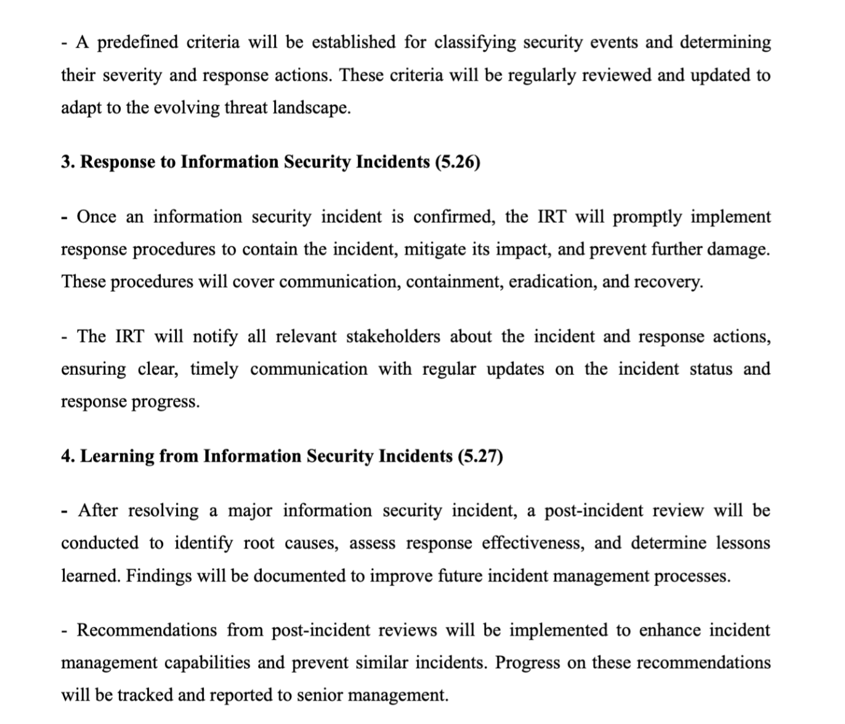

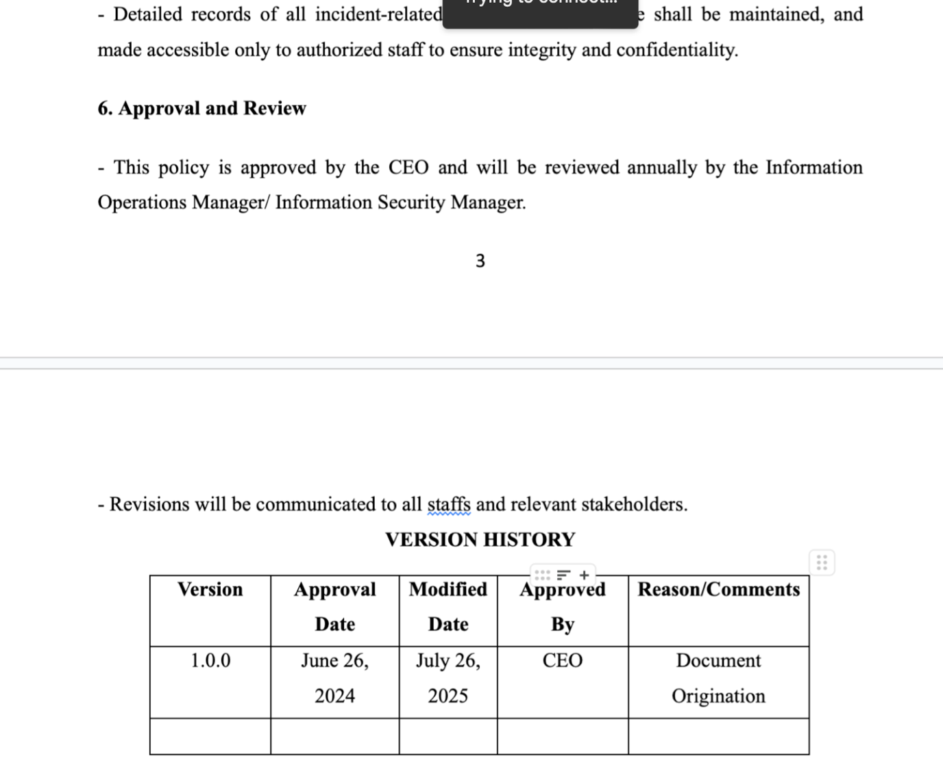

1. Identity and Access Management (IAM) Policy: **Domain:** Information security policy (A.5.), Organization of Information Security (A.6.), Access Control (A.9), Information Security Incident Management (A.16) Human Resources Security (A.7), Access control (A.9), **Sub-Domain:** Policies for Information Security, Segregation of Duties, User Access Management, Reporting Information Security Events, Information Security Awareness, Education and Training. **Control ID: 5.16**

This policy ensures that access to Cyanide’s information systems and data is granted only to auhtorized individuals and that their access is managed and monitored effectively. This policy aims to protect sensitive information, ensure regulatory compliance and reduce the risk of unauthorized access to organizational assets. This policy applies to all staff, contractors, vendors and anyone who have access to Cyanide’s information systems and data. It covers all systems, applications, networks and data repositories managed by or on behalf of the organization.

